Teacher of the Year
DEMOGRAPHIC INFORMATION

Nominee’s Information

Teaching Level
___Elementary | ___Middle School | _X_High School

Nominee’s First and Last Name
Tasha Candela

Nominator’s Information

Nominator’s First and Last Name
Jodie Kleymeer

Nominator’s School Phone Nominator’s Email Address
(586) 285-8916 | jkleymeer@lsps.org

Nominator’s Position/Title
Media Specialist

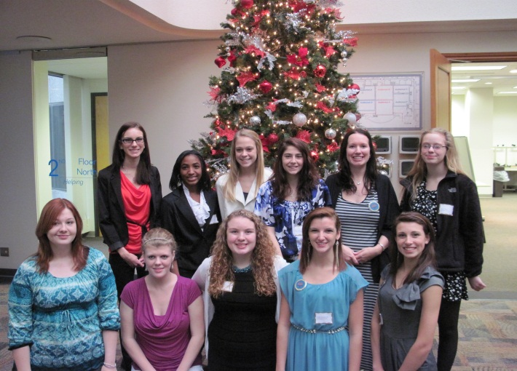
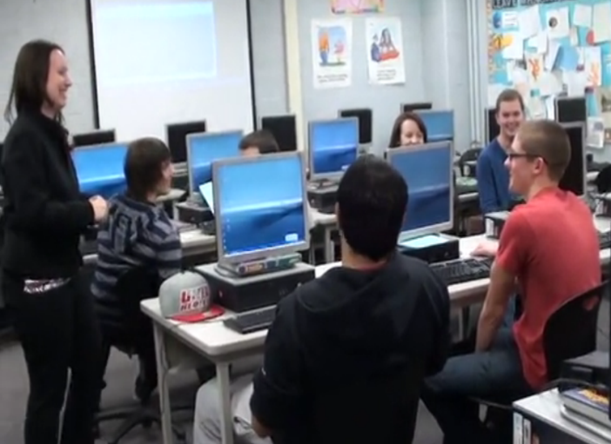

- Mission Driven and Passionate

As an alumnus of Central Michigan University, Tasha has many reasons to be proud of her education. She graduated cum laude with a major in Business Teacher Education, minor in English, vocational certification in business services, and holds her master’s degree in Educational Technology. Currently, she serves as a business instructor at Lake Shore High School teaching career/technology foundations, senior leadership, and web design courses; she has taught eighteen different classes with gusto. Her online portfolio can be visited at http://tashacandela.weebly.com. In addition to her teaching schedule, Tasha has worn several hats including the GET-IT Advisor (Girls Exploring Together Information Technology), Excellence, Spirit, Pride Advisor, underclassmen advisor, basketball coach, summer school teacher, member of the leadership committee, and technology trainer. She is currently pursuing national board certification. Her enthusiasm and love for this profession is unmatched and this is why I implore you to consider her for this award.
- Positive and Real – Demonstrates with parents, students, and colleagues

Respect, caring, empathy, and fairness for all students are vital in her classroom. Tasha builds relationships with each child and loves learning about the student’s strengths, weaknesses, learning styles, aspirations, home life, and extracurricular activities. She sets up collaborative teams based on diversity. She encourages all students to participate by giving them roles and sharing results side-by-side. She shows her appreciation for a job well done. Students share personal issues with Tasha because they trust and respect her. Her instruction is differentiated. ELL and Special Education students excel in her classes. Purchasing her specialized software for home use is unrealistic for most students so she is available after school hours. Sarah Woolsey said, “Mrs. Candela called me continuously and had entire email conversations with me just to make sure I made the contest deadline. She truly cares about each and every student like her own child.” See Student Support Statement.
- Teacher Leader

Tasha is rated highly effective by her administration and has won numerous awards for going above and beyond in the community and workplace. Three most recent awards include Barnes and Noble’s My Favorite Teacher contest winner, Central Michigan University’s Outstanding Recent Graduate Alumni Award, and the Michigan Association Computer User’s in Learning's Pre-K-12's Technology Teacher of the Year. These awards demonstrate how her leadership contributes much effort to educational processes and professional development using technology and how her technology lessons are used for academic achievement, motivation, attitude, and increased usage. Her students have been published in local, state, and national magazines because of their quality work with electronic portfolios and interactive websites. In addition, they have won cash prizes by submitting their sites to contests. She promotes technology integration with new and veteran teachers. As you can see, she sets high goals and achieves them on a regular basis.
- High-Level of Consciousness

Within Tasha’s daily routine, she greets students at the door in attempt to make a personal connection with every student. As soon as students enter the attractive and organized room, they login to her Edublog at http://bethetigger.edublogs.org and begin working. It is evident that Tasha teaches classroom procedures early and often. Humorous posters, student work, and additional resources are placed around the room conveying educational lessons. In past principal Betty Sands’ evaluation, she writes “Tasha makes use of multiple effective teaching strategies to engage students and keep them on task including guided practice, positive reinforcement, proximity to students, direct instruction, visual and auditory cues, connecting new content with prior knowledge, modeling, sharing/reflecting, interactive lecturing and constant monitoring. Tasha’s classroom environment and lessons are outstanding.” In addition, she regularly adapts lessons to fit the needs of new technology, new school improvement plans, new students, and most recently, the new Common Core.

- Teaching Style

Personal choice is always embedded into Tasha’s lessons. She challenges students to be creative with their website and portfolio content, layout, and graphics. She brainstorms ideas and gives examples with students, offering best practice tips before implementation. Tasha has personally written grants winning over $30,000 in gadgets to enhance the classroom. She uses Blackboard, email, digital cameras, projection devices, classroom response systems, spreadsheets, document formatting software, assessment tools, data warehousing systems, keyboarding shortcuts, blogging tools, collaboration tools, digital citizenship resources, digital tools for enhancing pictures, digital tools for creating an online presence, and video resources on a regular basis within her classes and regularly shares and trains these current technologies with others. Using these tools has increased student engagement and achievement. Tasha requires students to think outside the bubble sheet. She is truly a collaborative, creative, tech-savvy individual, willing to share her expertise with others and move the district ahead.

- Motivational Expertise

Tasha’s web design classes participate in an annual web design contest sponsored by the Michigan Council of Women in Technology. The contest is open to six counties in southeast Detroit. In December, the twenty-four finalists from area high schools present their websites to a panel of five business executives with the hope of winning a cash prize. For the past two years, Tasha’s students held the most finalists spots in all six counties earning back-to-back first place (beginner category) and second place (advanced category). By focusing on the student ownership, providing real world opportunities, and giving constant feedback, all students will excel. Behavioral issues are nonexistent because students are engaged. Lisa Nye commented, “I have never really been challenged with a class until I had Mrs. Candela for a teacher. She has taught me more than any other teacher has and everything she taught me can be applied to life.”

- Instructional Effectiveness

Tasha has made an earthquake impact on student achievement. She is well versed and knows how to get results. She pretests and posttests her students so she has direction for her instruction. From there, she maps out her courses with specific objectives and timelines that meet her content standards and benchmarks.

Research shows that, at the high school level, a student’s attention span is roughly 20 minutes in length and that students only retain about 5% of what they hear in lectures. This is why, after a short period of lecture and explanation, the classroom transforms into a student-centered environment where web design professionals in-training are coding, asking critical questions, communicating with one another, giving the whole class feedback, and reflecting in their blogs. While she is constantly providing constructive and insightful feedback that furthers student learning, the students are not focused on her. In fact, they are first turning to each other for input. They showed real value in peer comments and concerns. While she monitors progress, she coaches from the sidelines. She loves to see that ah-ha moment right away, but know that it is important for my students to demonstrate their learning and persevere through obstacles. This requires patience and a solid repertoire of instructional practices that will help all students, including those at-risk, reach their goals. Because of her successes with diverse abilities, she was asked to coteach a cognitively impaired class this year.

Companies hire web designers based on content knowledge and employability skills. Along with mastery of content, students use communication, teamwork, analyzing and investigating, initiative, drive, leadership, and time management. These soft skills are not simply taught through lectures and definitions. They are mastered through interactive, hands-on lessons. Her strong command of important career and technical education content and ability to link content and skills with workplace expectations, practices, and/or career exploration is to be applauded. Her passion for learning in this field has kept her abreast on the web design skills and content knowledge and high performance standards necessary for the workplace. These skills are providing students with opportunities to design websites for clubs at school, local and parent businesses, and beyond. They are truly making a difference in our community by using their coding knowledge as a hobby, a service, and an occupation.

Michigan State University student Corinne Anderson emailed Tasha and said, “They said after going through approximately forty resumes, mine had stood out as being the most professional. The resume I had sent, while having freshly updated information, was still basically the same in layout and guidelines as you had originally taught me. I begin on Monday, and am so excited, because I never thought the opportunity would even be mine to have! I really hope you know just how thankful I am that you really made sure that your students were prepared for a job.”

Her fervor to improve the quality of education for every student is one of the many reasons why Tasha is an exceptional educator.

- Life-Long Learner

Tasha is a life-long learner who actively seeks opportunities to learn and share new information and strategies with colleagues. She has been a presenter at seven local, state, and national conferences sharing with both parents and educators alike the power of technology. Because of these presentations, she has become a significantly better educator. Educators in varied disciplines have emailed and tweeted questions and compliments about her lessons. Not only have she been able to help others embed quality lessons into their own curriculum, she have also learned from them. These presentations have prompted discussions that have made her tweak lessons to improve their quality. She have also tweeted with educators across the world on a weekly basis about educational issues using #edchat, collaborated with cofounder of Weebly Dan Veltri, and absorbed new information on Lynda.com. Through her love for learning, she is staying current with best practices and instructional strategies.

- Community Focused

Tasha integrates the community in many facets of her lessons. Advanced Web Design partnered with Lakeshore Lanes, a local bowling alley, to make a website for the owner, Mr. LaHood. Students worked collaboratively with the company to ensure the website met the recommended specifications. Because of the project success, a feature article was published in the national journal, Leading and Learning with Technology. Tasha has arranged field trips to places like Mercedes Benz Financial Services, Compuware, and local colleges. Because of the connections she maintains with parents, these stakeholders are invited into her classroom to share their industry knowledge. Parents have access to all classroom information and student examples on her websites, inviting them to take part in activities. Through advisory committees, Tasha gains insights into what employers are looking for and she uses that information to prepare her students. She prepares professional development sessions on technology topics for staff/parents.

- Reflective Practitioner

Even with her enormous imagination, Tasha cannot possibly predict what the future holds in this field of study; there will never be an end to learning. Completing the national board certification process this year has strengthened her pedagogy. In career/technology foundations class, she has transitioned from paper portfolios to a digital presence. The quality of content within the portfolio, taken from economic changes, and employer/student suggestions, resulted in a trip to Microsoft’s Innovative Education Forum. Web Design classes have evolved from one beginner section with little software to six sections of beginner and advanced classes equipped with a Smart Podium, Photoshop, and Web Expression software. Technology is demanding subject which requires Tasha to read online articles, network with people across the globe, and view podcast tutorials. It is her vow to continue perfecting her craft with rigor, relevance, relationships, and results so that advancements within technology classes will occur.

Student Support Statement from Warren Rothe

In another class, senior Warren Rothe was required to give a speech about someone who exhibited leadership. Famous war heroes, presidents, or pop culture icons are all excellent choices. However, Warren decided to select Mrs. Candela after a mere 7 days as a student in her web design class. This demonstrates her immediate impact on students. Here are his notecards from class speech:

