C. Denomme

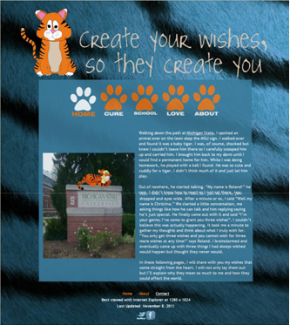
Teachers will always come and go and not leave anything with you. One teacher who has not just come and went was my favorite teacher Mrs. Candela. She is someone who influenced my life tremendously and I admire greatly. She always has your best interest at heart and sometimes will worry about your problems more than you will yourself. She only wants the best for her students and wants them to succeed in their schooling and life. She has made me work harder than any teacher I’ve ever had. Creativity is not my strength so when she pushes me to be more creative and I get an unbelievable outcome, I only love her more and more. She always knows that students are capable of so much more than they output and she will get it out of you. Throughout all four years of high school, she has taught me not only things useful in school but things that will be useful in life. Mrs. Candela can always brighten your day with her smile or her little jokes. A lot of kids dread going to school daily and sitting through class and I believe this is because every teacher makes kids do cookie-cutter assignments and read directly out of the book. Mrs. Candela never makes you do boring assignments and you don’t do the same things over and over. She is very unique and gives you assignments you would never see in any other class and probably any other schools near us, like our wish websites (right) we created this trimester. I love this about her.
Web design is a class and area of technology that not many kids venture into. It can be a challenging and very rewarding course and I love it. Mrs. Candela puts her whole heart and soul into a single class and having four classes a day, her whole life is into web design and helping students. She offers to come before and after school and even during her prep hour during the school day if you need help with anything. She is the happiest teacher all the time and even if she were to get mad it’s because she wants the best for you and wants to see you succeed. She has taught me so much about web design and the coding that comes with it. My classmates and I have succeeded tremendously with her help and I don’t know where I would be without her.
All in all, Mrs. Candela deserves this award be she really is my favorite teacher and the best. This award will allow her to further her teaching methods and help kids achieve something possibly even better than what they already have. I look up to Mrs. Candela so much and really don’t know what I would do without her. She has influenced my life so much and I appreciate all that she has done for. She and her teachings and chats with me will stay with me forever.

