Are you concerned about the contents of your digital footprint?

We’re not.

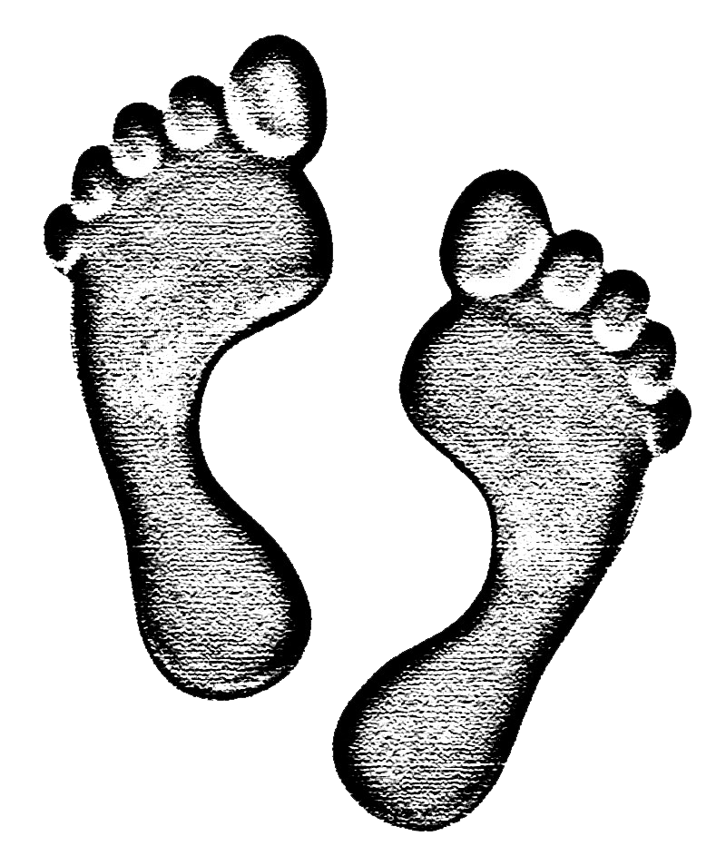

<http://angelavanderheyden.weebly.com>



<http://alexmardlin.weebly.com>



<http://paigelambert.weebly.com>



<http://lauraann13.weebly.com>



<http://justinmichael16.weebly.com>



http://kiananicole.weebly.com



Find us on Weebly today!