As a senior now in high school, I’ve had my fair share of inspiring teachers in the past four years of my life. But there is only one teacher that stands out above the rest, and that’s Mrs. Candela. She has inspired and helped me in many ways. The first time I had Mrs. Candela was my first tri in my freshman year. At that point in time, I was scared to be in high school. I was not excited at all. But after a while I looked forward to Mrs. Candela’s class. After leaving that class, I was more excited for high school.
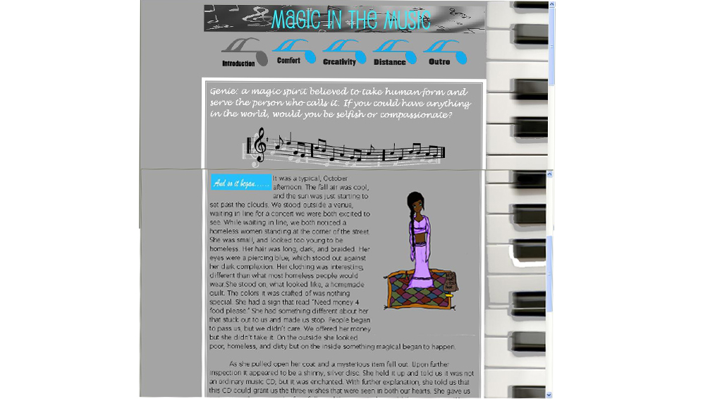
I didn’t have the privilege of having Mrs. Candela again until my senior year. The class was Advanced Web Design, and it was an amazing experienced. Using the limited programs we had, we learned Photoshop and CSS coding. During learning these skills, we were also working on websites. These websites were being entered into an all girls web design contest that was opened three counties wide. Some of these schools had been learning Web Design and Graphic Design skills for years, and had way more advanced programs to help them. There were two categories to enter, Beginner and Advanced. We worked furiously, using the few available programs we had to design these websites. Mrs. Candela pushed us to come up with extremely creative and wonderful idea for our websites, helping us the whole way through. She also pushed that most of the graphics we used be original, so she had us draw our own genies for the webpage. In the end, 12 girls total placed, including myself. 7 out of 13 in the advanced category were from our school. If it wasn’t for Mr. Candela being there and helping us best she could with the limited resources we had, I have a feeling we wouldn’t of had such a wonderful turnout.
If it wasn’t for the class, I wouldn’t know that I have a talent for graphic design, and know the possibility of going into it as a career. I just took the class because I enjoy web design, and I knew that Mrs. Candela was teaching. It was an extremely wonderful experience, and now I get to present my website in front of huge, important people, for a chance to win a prize. Mrs. Candela pushed every one of us to do our best and to work hard, and it paid off. She just wants to see us to succeed and work to our full potential, this is why I find her one of the most inspirational teachers I’ve ever had.

