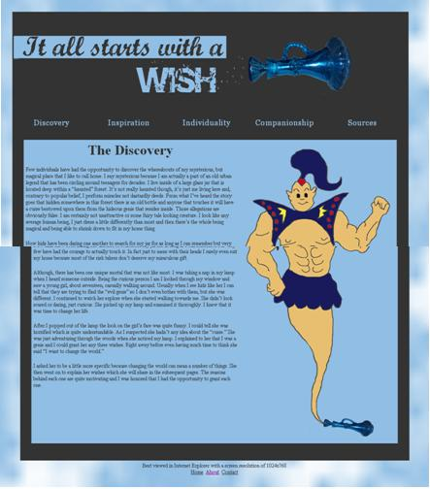
High school is a journey that has always been fairly easy for me. I have never really been challenged with a class until I had Mrs. Candela for a teacher. I have been enrolled in four classes that she has taught which include: Career Technology/Foundations, Web Design, and two classes of Advanced Web Design. I can honestly say that these four classes have been the only ones that have made me a different person and that is all thanks to Mrs. Candela.
The one class that has changed me for the better was Advanced Web Design. The second time I took this class, we were assigned to create a website as a part of a contest in which we could win money. This was the most time consuming and meticulous project I have ever undergone and I know my mindset towards school has altered. Mrs. Candela is not like most teachers. She actually cares about her students. Most teachers I’ve had just give their students work and don’t even know anything about who their students really are. Mrs. Candela knows everything about everyone though. She likes to know what is going on in our lives so she can develop beneficial ways to help us with our academics. It is helpful for me because when I need help, I’m not afraid to ask. Since I feel so connected, I know that she will help me in every way possible so I can succeed. Mrs. Candela has also taught me more than any other teacher has and everything she taught me can be applied to my life in the future. The skills I have absorbed in her classes will benefit me in tasks that may arise later in life.
Not only has she helped me during school hours, she has also helped me outside as well. She has provided me with many scholarship opportunities and gave me the confidence I needed to do well. She has taken so much time out of her own personal schedule to help her students and that’s more than I can say for any other teacher I have been enrolled with. I will always appreciate the work she has done for me and how much she has cared about me. Mrs. Candela will always be one of my favorite teachers and I am so grateful of having the opportunity to have her teach me.

