Macomb Daily: Macomb students among hundreds who demonstrate technology to lawmakers
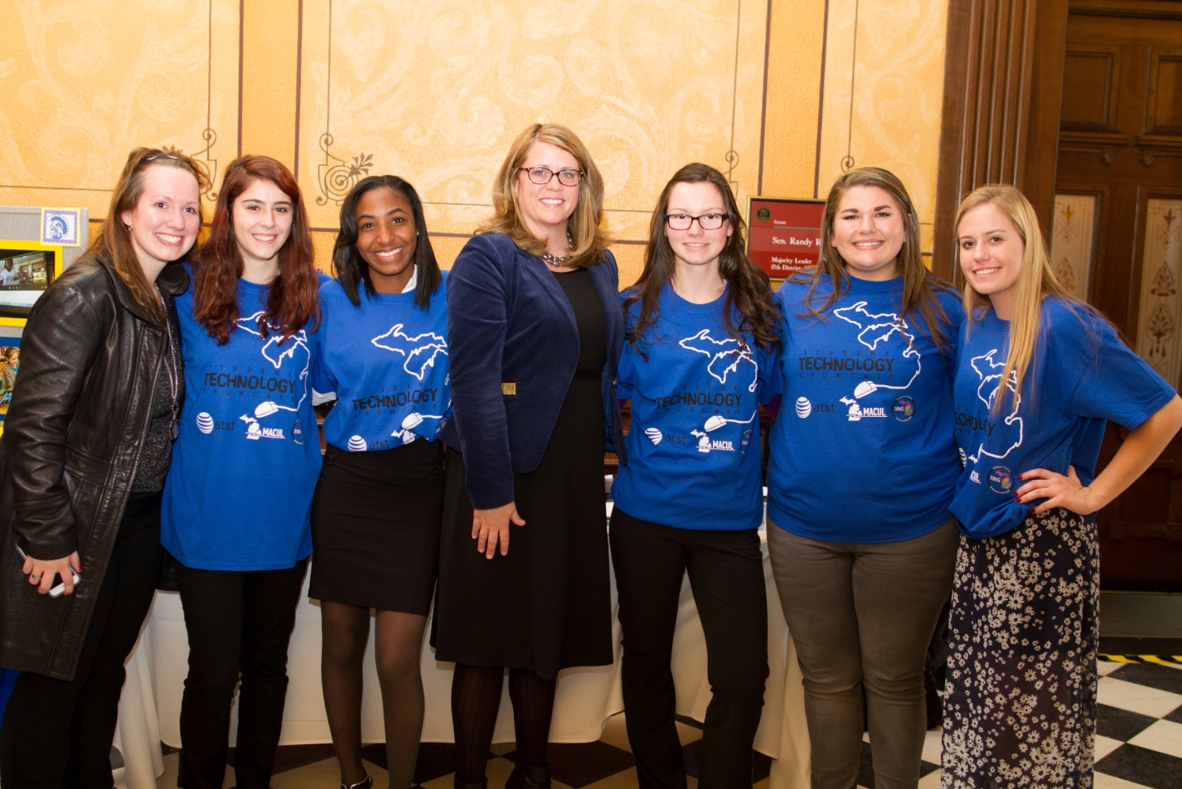

Students from Lake Shore High School who participated recently in the 14th annual AT&T/MACUL/TRIG Student Showcase at the Michigan State Capitol Building included, from left: Teacher Tasha Candela, Hailey Lynch, Dasha Jones, Representative Sarah Roberts, Megan Kovalcik, Gabby Lopreiato, and Brooke Glass.
Macomb County students joined hundreds of others from around the state recently to demonstrate to state lawmakers how technology is used in the classroom.
The 14th annual AT&T/MACUL/TRIG Student Showcase at the Michigan State Capitol Building featured students from elementary school through high school.
The program was presented by the Michigan Association for Computer Users in Learning, and underwritten by AT&T and TRIG.
“Every day, students and educators in Michigan are embracing technology to create new and exciting opportunities to learn,” said Jim Murray, president of AT&T Michigan. “AT&T is excited to help make their inspirational work possible, through expanded access to the Internet, new technology and high-speed mobile broadband that connects students to each other and to learning like never before.”
Projects covered a wide variety of learning areas including science, mathematics, social studies and language arts; featured paperless classroom and online learning demonstrations; included a presentation from elementary school computer coding clubs,; and robotics demonstrations from high school students who have partnered with Michigan job makers to learn advanced skills for 21st century jobs. One high school class showcased its work to help combat human trafficking.
“Students are using technology in remarkable ways,” said Mark Smith, executive director of MACUL. “This showcase gives lawmakers just a small taste of the ways schools and students are using technology to impact their education, expand their learning opportunities and to make a difference in the world.”
Macomb County schools represented at the showcase included Erie Elementary in Clinton Township and Jefferson Middle School and Lake Shore High School in St. Clair Shores.

