I would first like to start off by saying that my teach Mrs. Candela has had a great effect on life in more ways than one. I will be forever grateful for the things I have learned from her. She has taught me so much in my three years at Lake Shore. I am so privileged to have been able to have had her at least once every year. She has taught me just about everything I know about computers and have helped be realize what I want to do when I get out of high school. She is always willing to help and answer any question; some simple and sill but she still cares. I remember growing up I didn’t know what I wanted to do after high school/college. Then when I got into high school I had her and she made me realize my love of computers and art. Below is a poem that I wrote about having her as a teacher.

Having you as a teacher is the best thing ever.

Without you here do I freak out, no never!

I have learned things what will last a life time.

They just spin and spin on a dime.

I can’t believe that I have one more year.

It’s hard to believe that I’m almost done here.

Leaving you will be the hardest thing ever.

But our bond I know will never be severed.

Every class that I have of hers I learn so much. My favorite class that I took was Advanced Web Design. I continued to learn about HTML coding which I had learned in the beginning class; also we learned Photoshop. Learning about Photoshop was very fun; I was able to edit the pictures that I had and get them the way I wanted. In Advanced Web Design we were presented with a contest that was generously sponsored by the Michigan Council of Women in Technology. Mrs. Candela has not only taught me about school but about life. I have learned so much from her and I am forever appreciative.

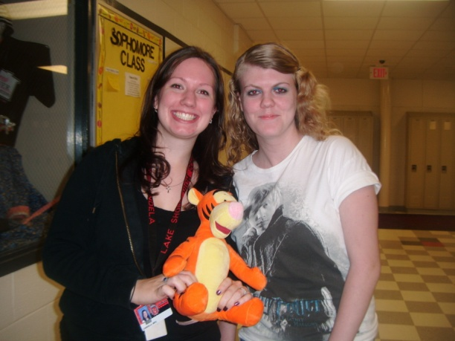-Renee A. Alter