Victoria Vigliotti
Tasha Candela
Advanced Web Design
Lake Shore High School

I love Mrs. Candela!
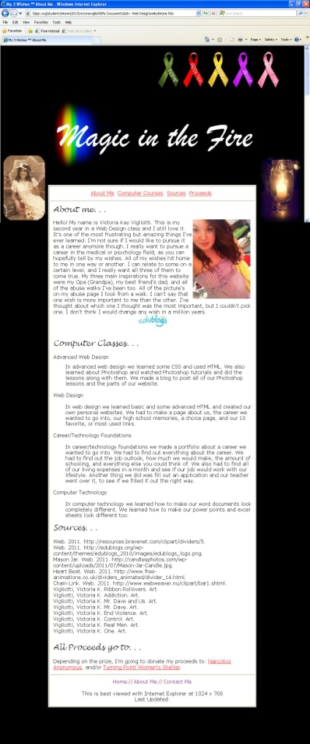
The web design contest I chose to entered because of Mrs. Candela was amazing overall. It helped me expand my knowledge on coding and Photoshop and made me realize what I could and couldn’t do. This also made me realize that maybe I do not want to pursue a career in web design. This class made me open up and let me share some of my stories and made me grow as a person. I was very grateful for this opportunity and I would not change it for the world. I had an amazing experience in this classroom; I opened up more than I have to anyone except my therapist because this class gave me the opportunity to. Mrs. Candela has done wonderful things for me. She has really helped me through a lot, without her even knowing. I am so grateful that I have gotten to know her, and am happy that everyone in this class and others in this school has gotten the chance to get to know her. Working in the room everyday with Mrs. Candela was great too. She really helped me expand my knowledge on everything; including life. I love her as a person, and would never want her out of my life. I would never want any other teacher to teach me this class; she makes learning new code more interesting just by how she acts. She is excited to see us every day and never turns us down. She is always there when you need help, and she would never let you down. I know that I would not be the way I am if I was not in her class. This class is my first hour (thank goodness) because if I had economics my first hour I would never be excited to come to school. I really appreciate everything she does for us because she really goes out on the limb just to help us. She is always caring and considerate of us, and I have had some amazing conversations with her. I wish for everyone to have the amazing experience of getting to know her and I really hope that she never leaves this school. I am jealous of her baby, because she gets Mrs. Candela as a mom, and having her as a mom sounds pretty darn good to me. You are the best teacher I have ever had Mrs. Candela; you’re an amazing person and you deserve the best.
Sincerely,
Victoria Vigliotti

