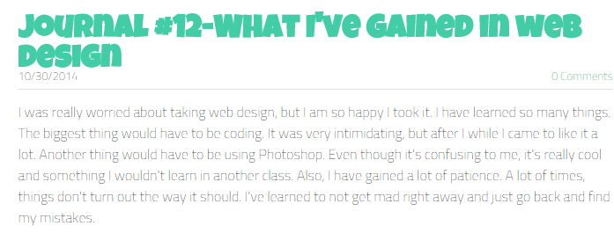

THANKS TO THIS CLASS....
10/30/2014
0 Comments

I learned how to use my brain to create art that is not created by a pencil or pen. In this class I'm actually able to put my mind fully into this course, and I'm able to accomplish wonders. I don't have a hard time and struggle, because this is not a learn memorize and take a test type of class. It a learn it, apply it, test it, see result, and continue on. We are always reusing the things we learn from day 1. There is not Unit 1 or 2 to move onto and forget the old. This is a refreshing class, with a fun environment.
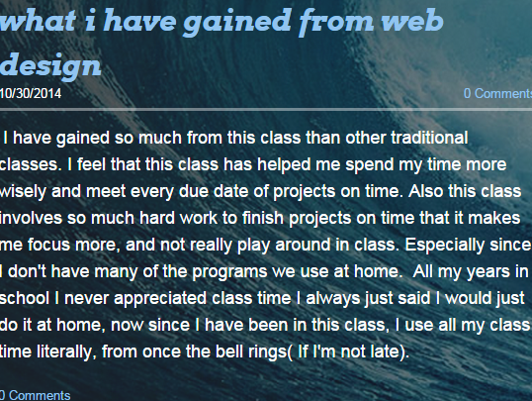

Hai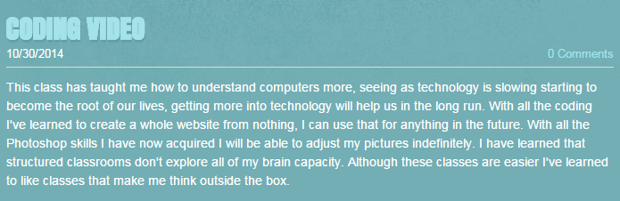
I have gai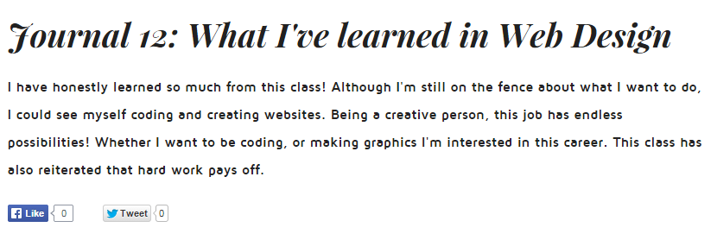ned so much from this class than other traditional classes. I feel that this class has helped me spend my time more wisely and meet every due date o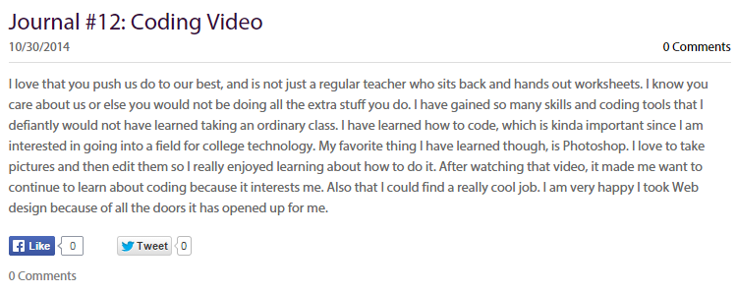
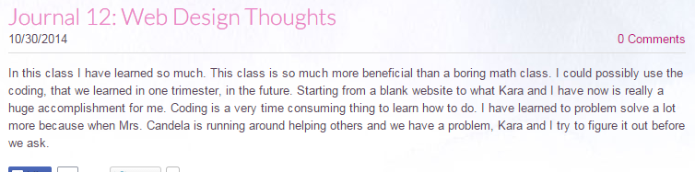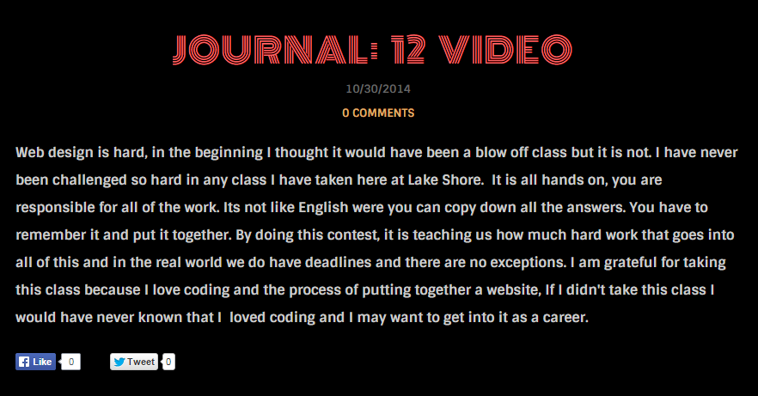
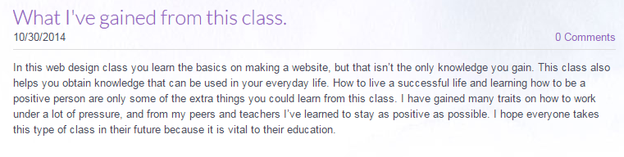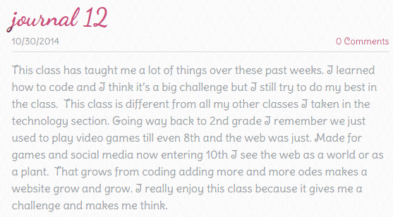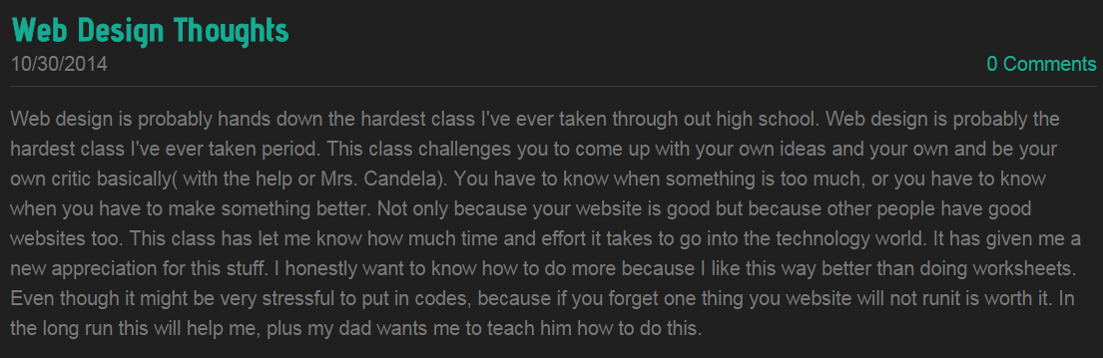
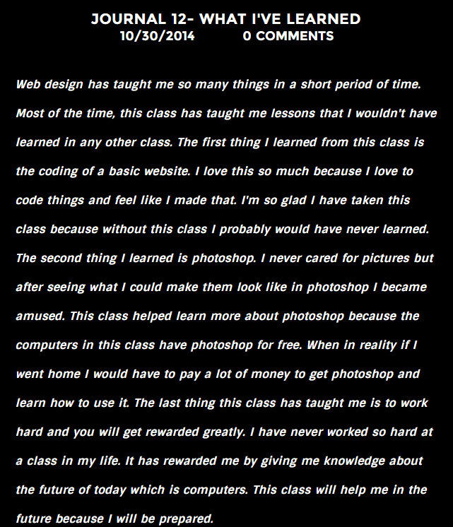

f projects on time. Also this class involves so much hard work to finish projects on time that it makes me focus more, and not really play around in class. Especially since I don't have many of the programs we use at home. All my years in school I never appreciated class time I always just said I would just do it at home, now since I have been in this class, I use all my class time literally, from once the bell rings( If I'm not late).

